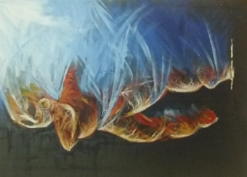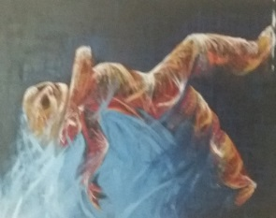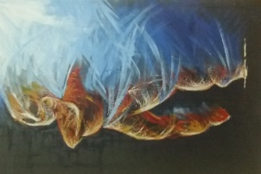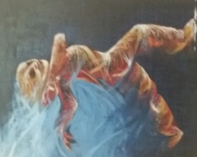

Er mwyn dathlu Wythnos Ddiogelu cafodd pobl ifanc CADW eu hysbrydoli gan y lluniau uchod wrth guddio eu hunaniaeth wrth fod ar-lein.

Mae eu lluniau'n cuddio eu rhyw, eu hoedran a'u lleoliad.

Fe wnaeth Chris Best ffotograffau lluniau y gallwch eu gweld yn y fframiau yma heddiw tra bod y bobl ifanc ar y preswylfa CADW a gynhaliwyd yng Nghwm Elan.  
Crëwyd masgiau mewn gweithdy a hwyluswyd gan Rush o Drenewydd Powys.

**Byddwch yn ddiogel pan fyddwch ar-lein**

**(**

**Gwasanaeth Eiriolaeth Canol A Gorllewin Cymru**

**)**

**Mid and West Wales Advocacy**

[midandwestwalesadvocacy@tgpcymru.org.uk](mailto:midandwestwalesadvocacy@tgpcymru.org.uk)

Byngalo Min y Mor, Gerddi Wellington, Aberaeron SA46 0BQ

Ffôn: 01545 571865 / 0808 1682599

**TGP Cymru yw enw gweithiol Tros Gynnal Plant. Elusen Gofrestredig Rhif 1099878. Cofrestrwyd yn gwmni cyfyngedig drwy warant Rhif. 04422485 (Cymru a Lloegr). Swyddfa gofrestredig: 12 Ffordd y Gogledd Caerdydd CF10 3DY.**

To celebrate Safeguarding Week the young people of CADW were inspired by the above pictures in hiding their identity when being online.

Their photos hiding their gender, age and location.

Chris Best took the photographs you can see framed here today whilst the young people were on the CADW residential held at Elan Valley.

Masks were created at a workshop facilitated by Rush of Newtown Powys.

**Be safe when online.**

[midandwestwalesadvocacy@tgpcymru.org.uk](mailto:midandwestwalesadvocacy@tgpcymru.org.uk)

Min y Mor Bungalow, Wellington Garden, Aberaeron SA46 0BQ

Tel 01545 571865 / 0808 1682599

**TGP Cymru is the working name of Tros Gynnal Plant. Registered Charity No. 1099878. Registered as a company limited by guarantee No. 04422485 (England and Wales). Registered Office: 12 North Road Cardiff CF10 3DY**

