

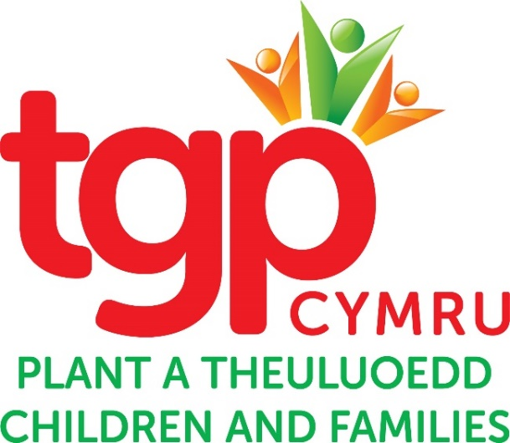

**Manifesto for the Senedd**

**Elections 2021**

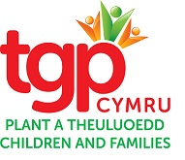**Submitted by TGP Cymru**

**A Manifesto for the Senedd Elections 2021**

**Context**

TGP Cymru is a Children’s Charity based in Wales. Formally known as Tros Gynnal Plant, the organisation was set up in 2002 to take over the work of the Children’s Society when they decided that they would no longer be working in Wales.

TGP Cymru is now the leading advocacy provider of independent advocacy services for children and young people, holding four out of the six regional contracts in Wales (15 out of 22 local authorities). We also provide Residential Visiting Advocacy Services in Children’s Homes, Residential Schools and In-Patient Health settings.

Other services include restorative engagement services for veterans and their families and in recent months, we have developed one of the fastest growing services to support Care Leavers with homelessness issues across North Wales.

We have been facilitating Junior Safeguarding Boards, like the “Safe Stars” service in Ceredigion and “Eat Carrots Be Safe from Elephants” in Powys for over 15 years, as well as leading the field in Restorative Engagement, Safeguarding and Advocacy Training for professionals and volunteers.

In addition, TGP Cymru provides community based consultation and advocacy services for Gypsy Traveller and Roma families as well as Refugee and Unaccompanied Children and Young People. More recently, we have been helping EU citizens and their families resident in Wales to access their rights and make applications to remain after Brexit.

Early in 2020, TGP Cymru launched research into Residential Visiting Advocacy Services (RVA) in Children’s Homes across Wales. The research, entitled ‘Out of Sight - Out of Rights?’, was funded by Welsh Government, and can be found on our website. It highlighted that of the 178 children’s homes in Wales, 155 were privately owned and 23 were owned by the Local Authorities. Of these, all the Local Authority homes provide a visiting advocacy service, but less than 10 percent of the independently run homes do so. RVA is an added safeguard, and a trusted and independent person to regularly visit these children was a major recommendation of the Waterhouse enquiry in 2000. You can see from the research findings that this has yet to be enacted.

During the disruption caused by the COVID-19 pandemic TGP Cymru continued to deliver services to the most vulnerable and most marginalised children, young people and families throughout Wales. We fed their experiences through to the Welsh Government’s Vulnerable Children Group and Gypsy, Roma and Traveller Team; The Senedd Children and Young People and Education Group and the Cross Party Group on Looked After Children.

Using this experience and expertise we have developed our manifesto with four asks:

1. To further safeguard children and young people who are living in residential settings by making Residential Visiting Advocacy a requirement of Registration and Inspection for all children’s homes and residential schools in Wales.
2. To embed the National Approach to Statutory Advocacy (NASA) and the Active Offer into practice by ensuring that there is a Commissioning Framework for Independent Advocacy Services for Care Experienced Children, and ongoing collation of the statistics as part of a National Reporting Framework for NASA. The National Assembly for Wales can use this information for future planning and celebrate this achievement as no other country in the world has managed this.

1. To require Health and Education to commission Advocacy Services for Children and Young People in line with the National Approach to Statutory Advocacy. This will enable all children and young people to have support to access their rights under the United Nations Convention on the Rights of the Child and to access the best education and health services available, particularly mental health services.
2. To ensure that when Welsh Government and public bodies are making decisions, discharging their public sector equality duty and designing and resourcing services including advocacy, they champion and take account of the specific experiences and barriers faced by Gypsy, Roma, Traveller, migrant, refugee & asylum seeker young people and families who continue to experience high levels of inequality and discrimination in Wales.

To include specific measures for these groups to ensure equal access to education, healthcare, culturally appropriate accommodation and employment; and that Welsh Government in its post-Brexit strategy ensures that EEA citizens’ rights and access to services are protected after the UK leaves the EU.

TGP Cymru will be engaging with many of our stakeholders and partners over the coming weeks to share this Manifesto and will be seeking wider endorsement upon completion. We will plan a launch event for our Manifesto early in 2021.

**Engagement**

We are also keen to meet with political parties in Wales to discuss our priorities. We are now in a position to arrange remote meetings with Members leading on party manifestos, and would welcome an opportunity to meet with you at your earliest convenience.

Thank you so much for taking time to read this manifesto, if you require any further information please do not hesitate to contact me at **jackie.murphy@tgpcymru.org.uk**

**Jackie Murphy**

**CEO TGP Cymru**

**August 2020**



**TGP Cymru yw enw gweithiol Tros Gynnal Plant. Elusen Gofrestredig Rhif 1099878. Cofrestrwyd yn gwmni cyfyngedig drwy warant Rhif. 04422485 (Cymru a Lloegr). Swyddfa gofrestredig: 12 Ffordd y Gogledd Caerdydd CF10 3DY.**

**TGP Cymru is the working name of Tros Gynnal Plant. Registered Charity No. 1099878. Registered as a company limited by guarantee No. 04422485 (England and Wales). Registered Office: 12 North Road Cardiff CF10 3DY.**

**TGP Cymru yw enw gweithiol Tros Gynnal Plant. Elusen Gofrestredig Rhif 1099878. Cofrestrwyd yn gwmni cyfyngedig drwy warant Rhif. 04422485 (Cymru a Lloegr). Swyddfa gofrestredig: 12 Ffordd y Gogledd Caerdydd CF10 3DY.**

**TGP Cymru is the working name of Tros Gynnal Plant. Registered Charity No. 1099878. Registered as a copany limited by guarantee No. 04422485 (England and Wales). Registered Office: 12 North Road Cardiff CF10 3DY.**